Sri Lanka Institute of Information Technology



Research Project

IT4010

B.Sc. (Hons) in Information Technology

Status Document - 01

Group ID: 23-139

Registration Number: IT20037888

Full Name: Ranasinghe J.D.

Specialization: Data Science

**TABLE OF CONTENTS**

1.WORK BREAKDOWN STRUCTURE 3

2.GANTT CHART 4

3.TEAMS PLANNER 5

3.1 TEAMS PLANNER BOARD 5

3.2 TEAMS PLANNER CHART 6

3.3 SCHEDULE 7

4.GIT COMMIT HISTORY 9

4.1 COMMITS 9

4.2 GIT GRAPH 10

5.MEETINGS 11

5.1 MEETINGS WITH THE SUPERVISOR (MR. SAMADHI RATHNAYAKE) 11

5.2 MEETINGS WITH THE CO-SUPERVISOR (MS. DEVANSHI GANEGODA) 13

5.3 MEETINGS WITH THE EXTERNAL SUPERVISOR - PYSCHOLOGIST (MS. AROSHA DASSANAYAKE) 13

5.4 MEETINGS WITH THE EXTERNAL SUPERVISOR – CEO AT XINOTECH (MR. THILANGA JAYARATNE) 14

# WORK BREAKDOWN STRUCTURE

The work breakdown structure is a hierarchical decomposition of a project or task into smaller, more manageable components. The plan of our work breakdown structure for the research project duration is as shown in the following.

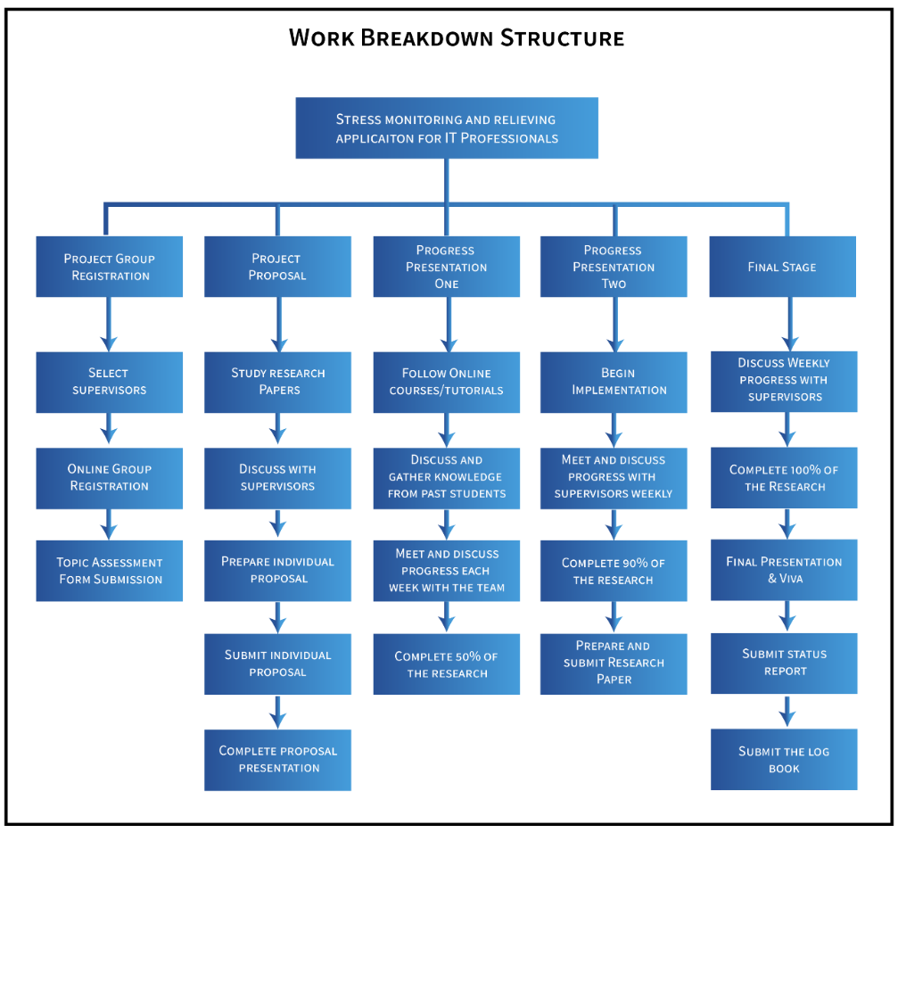

# GANTT CHART

A Gantt chart is a popular project management tool used to visualize the schedule and progress of tasks or activities over time. The Gantt chart which we designed to plan our progress is as shown in the following diagram.

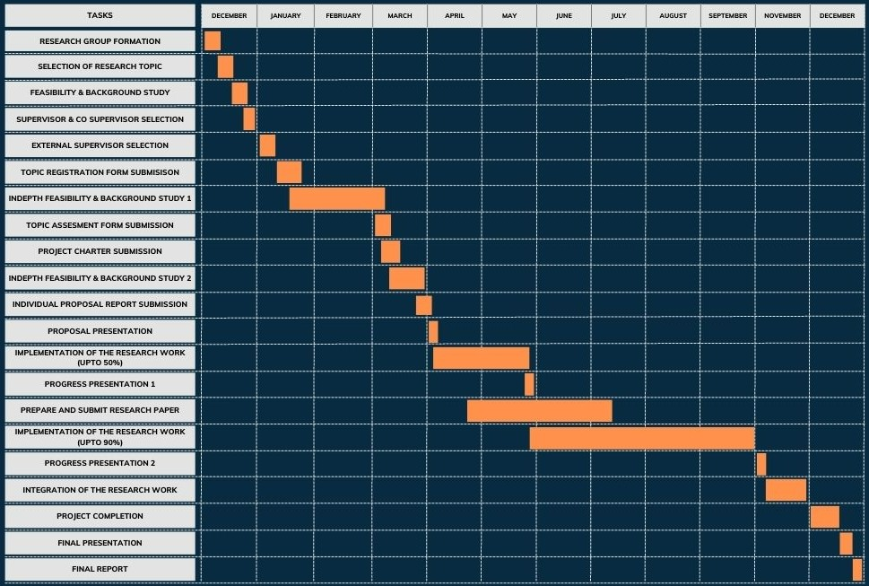

# TEAMS PLANNER

Microsoft Teams Planner is a project management and task tracking tool integrated within the Microsoft Teams collaboration platform. We used this platform to help us organize, assign, and track tasks, enabling effective teamwork and project management.

## 3.1 TEAMS PLANNER BOARD

The following interface provides a visual representation of tasks using a Kanban board-style layout. It offers a more visual and intuitive way to manage and track tasks within a project.

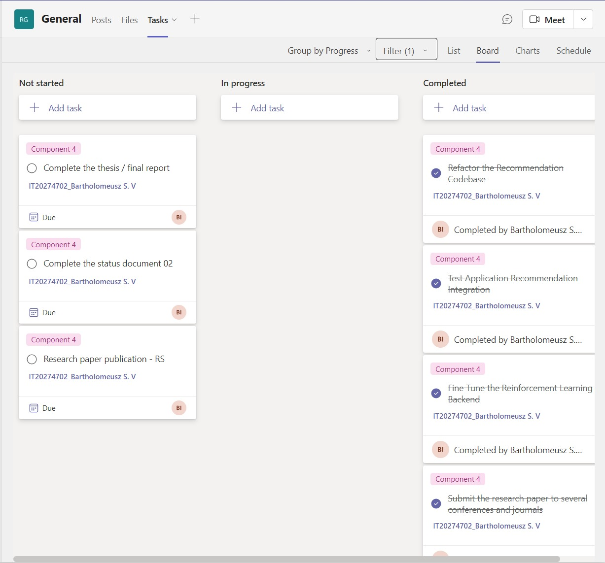

## 3.2 TEAMS PLANNER CHART

The following chart gives an overview of the current progress of the task list as a graphical representation.

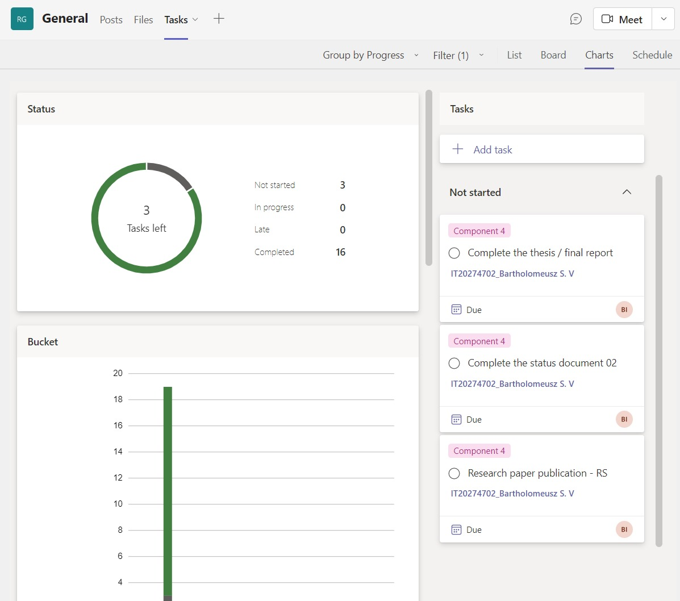

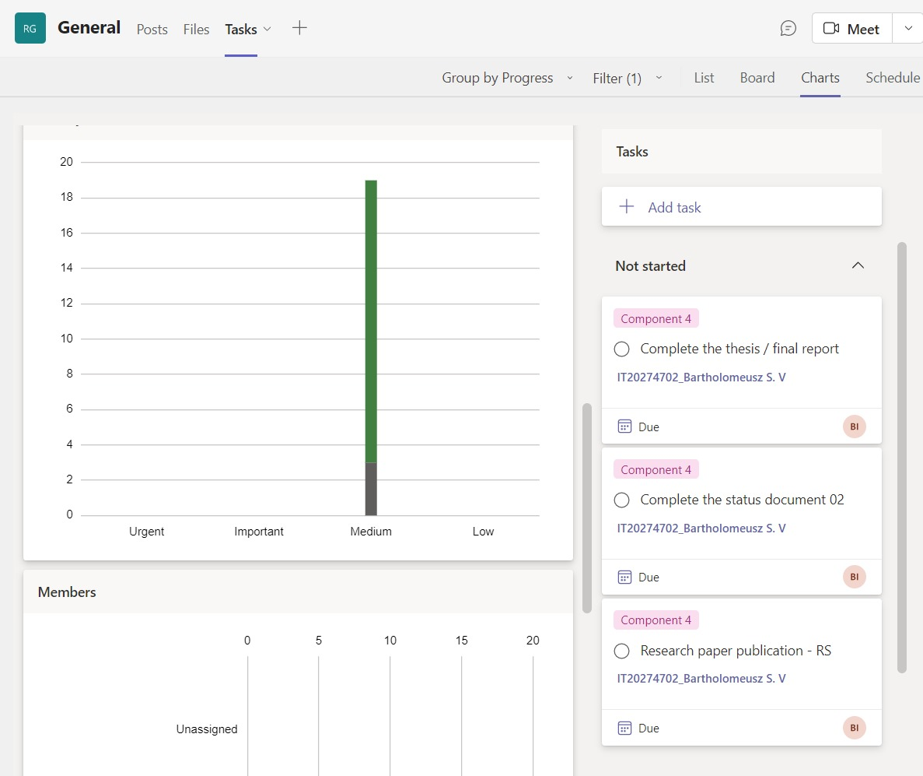

## 3.3 SCHEDULE

In Microsoft Teams Planner, you can schedule tasks and set due dates to create a timeline for your project or plan. The following calendar shows an overview of a few of the important dates that are set for the research project duration.

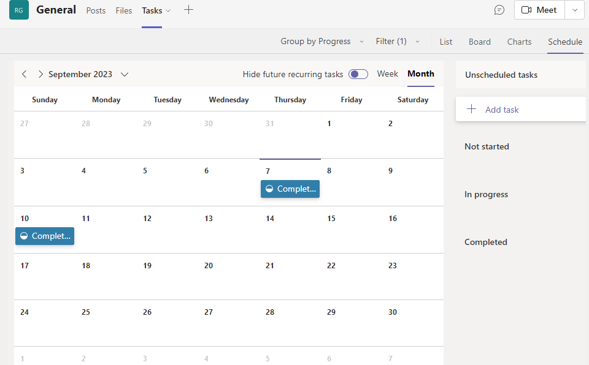

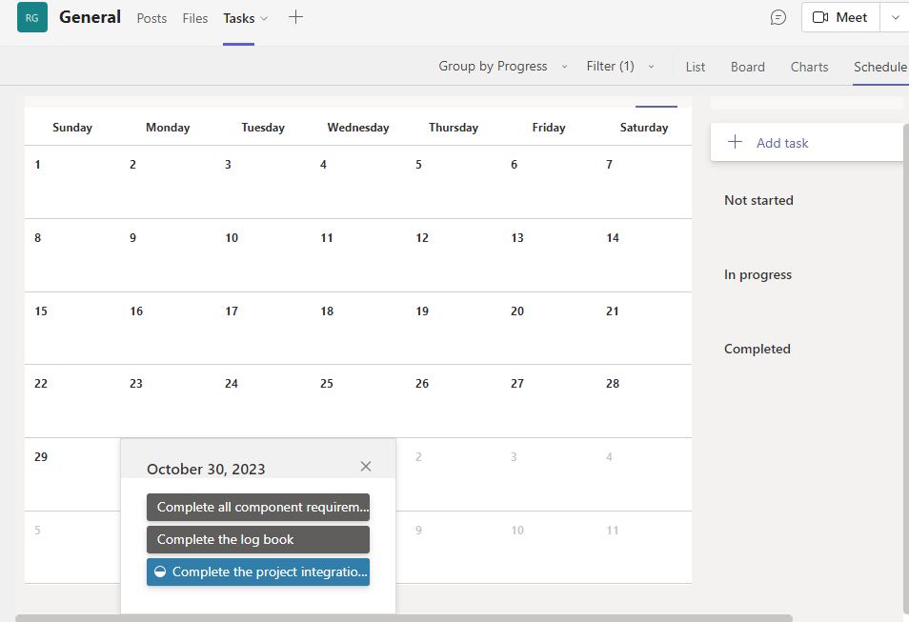

# GIT COMMIT HISTORY

Git commit history refers to the chronological record of commits made to a Git repository. Each commit represents a snapshot of changes made to the files in the repository at a specific point in time.

## 4.1 COMMITS

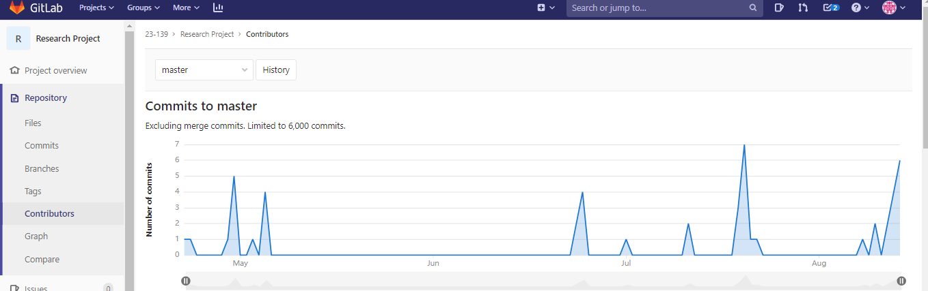

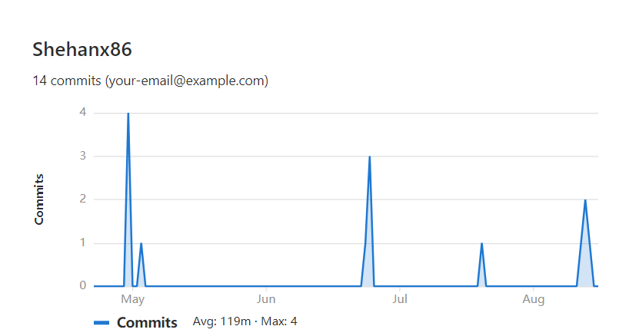

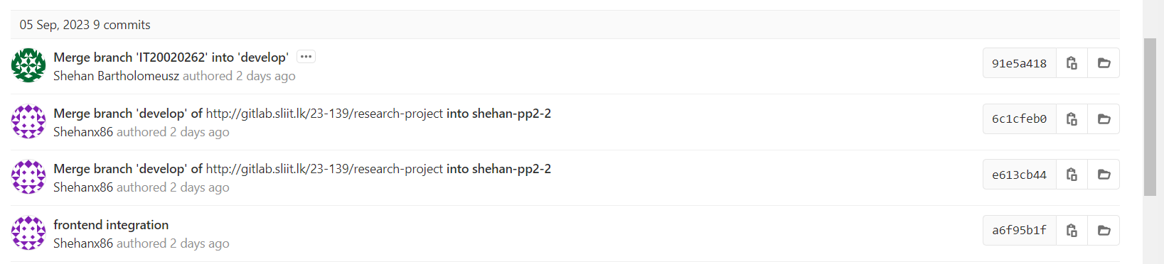

## 4.2 GIT GRAPH

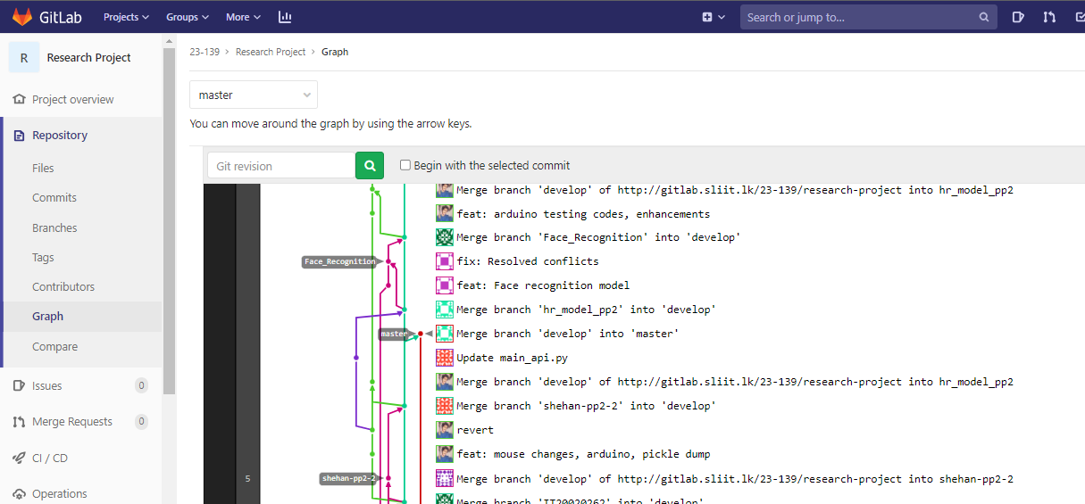

# MEETINGS

## 5.1 MEETINGS WITH THE SUPERVISOR (MR. SAMADHI RATHNAYAKE)

As a team, it is necessary to obtain proper guidance from the supervisor to complete the project successfully. Supervisor guidance is crucial for a research project as it provides valuable expertise, support, and mentorship throughout the research process. The following are the details of the meetings that were conducted with the supervisor.

|  |  |  |
| --- | --- | --- |
| **Date** | **Reason** | **Mode** |
| 08/06/2023 | Discussion regarding the research paper publications | WhatsApp call |
| 23/06/2023 | Discuss about the NBQSA nominations | WhatsApp call |
| 30/07/2023 | Discuss about the current progress of the research | Physical |
| 13/08/2023 | Progress of the research papers | Zoom |
| 18/08/2023 | Met to get the declaration form with the sign filled for the NBQSA competition | Physical |
| 30/08/2023 | Discuss the updates of PP2 and to give guidelines for the presentation | Zoom |
| 03/09/2023 | Discuss any issues before the PP2 viva | Zoom |

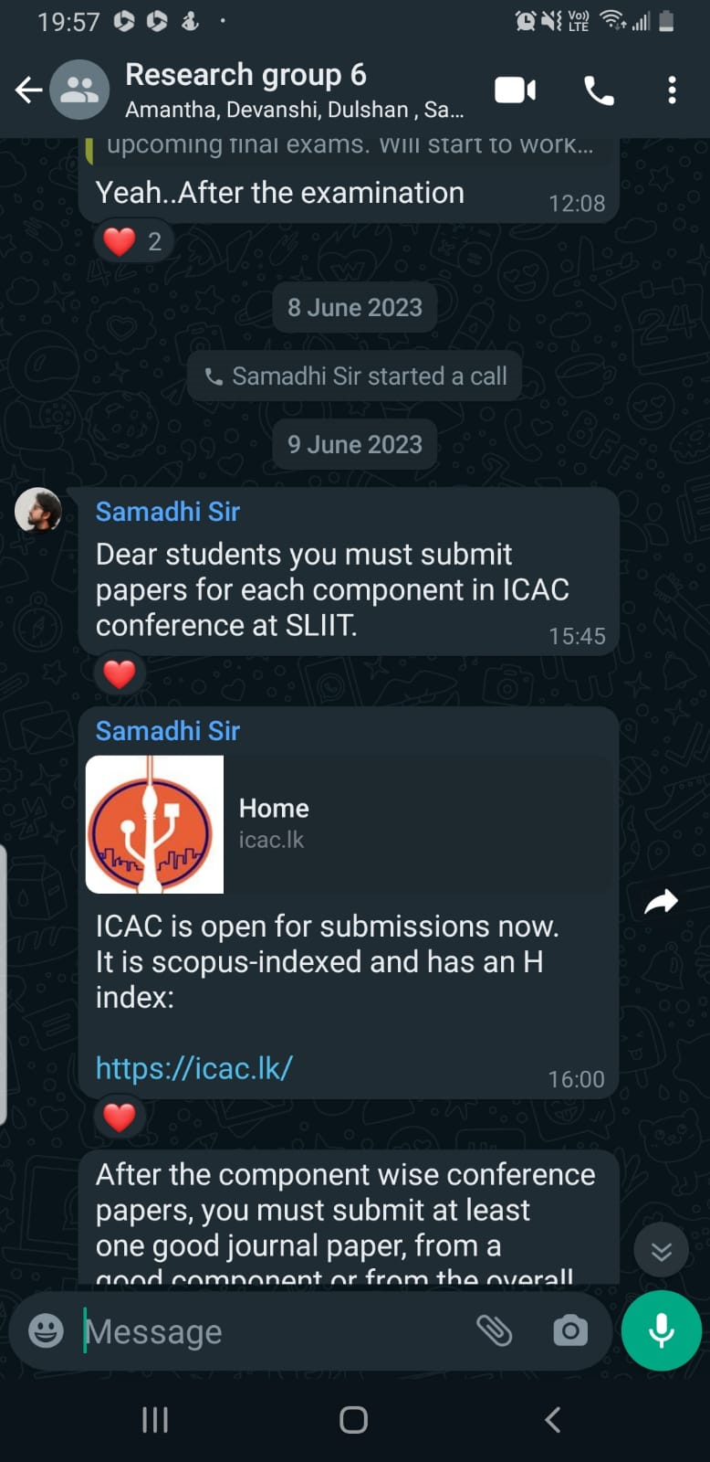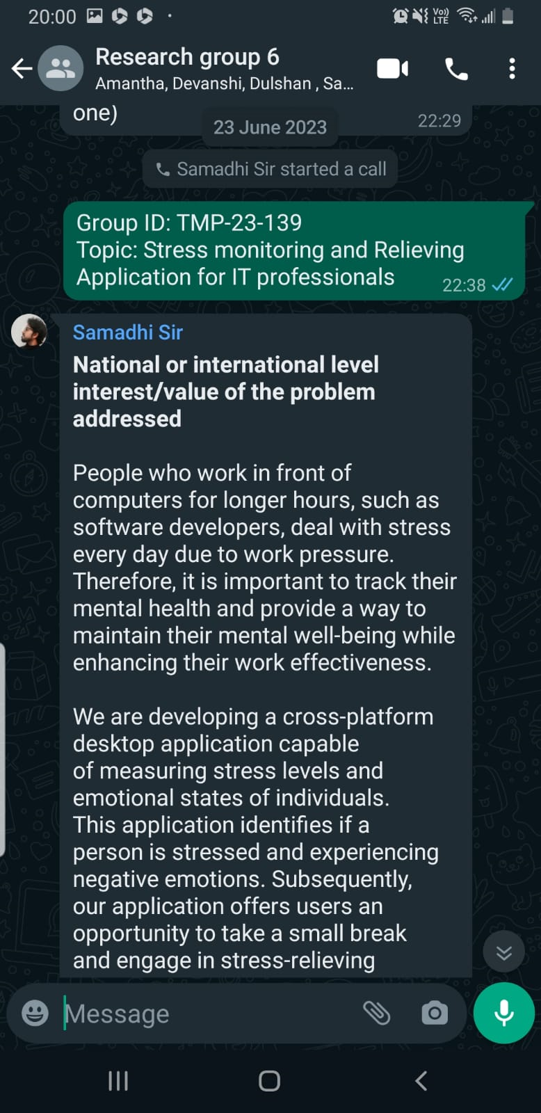

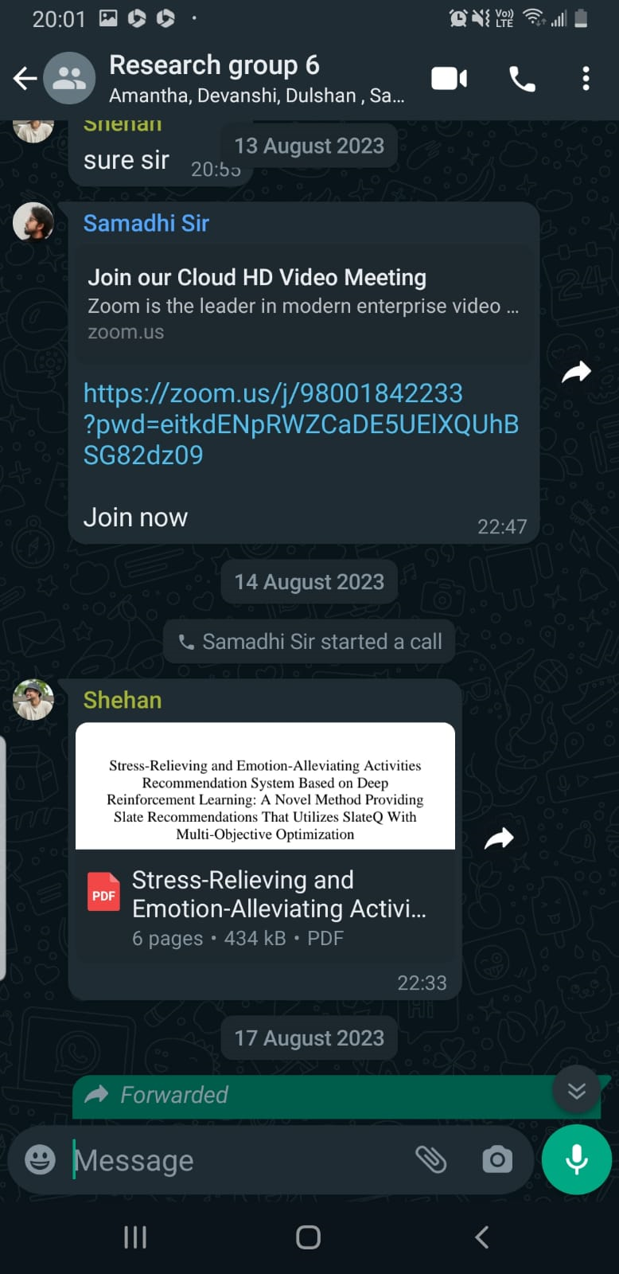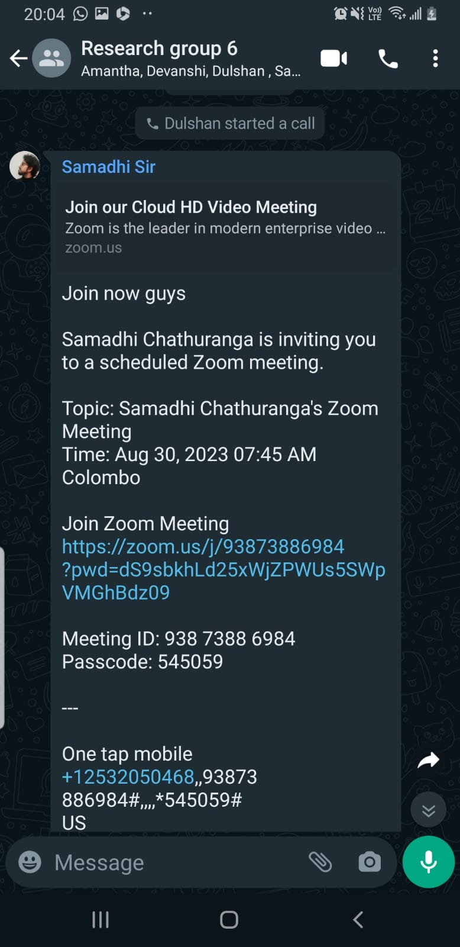

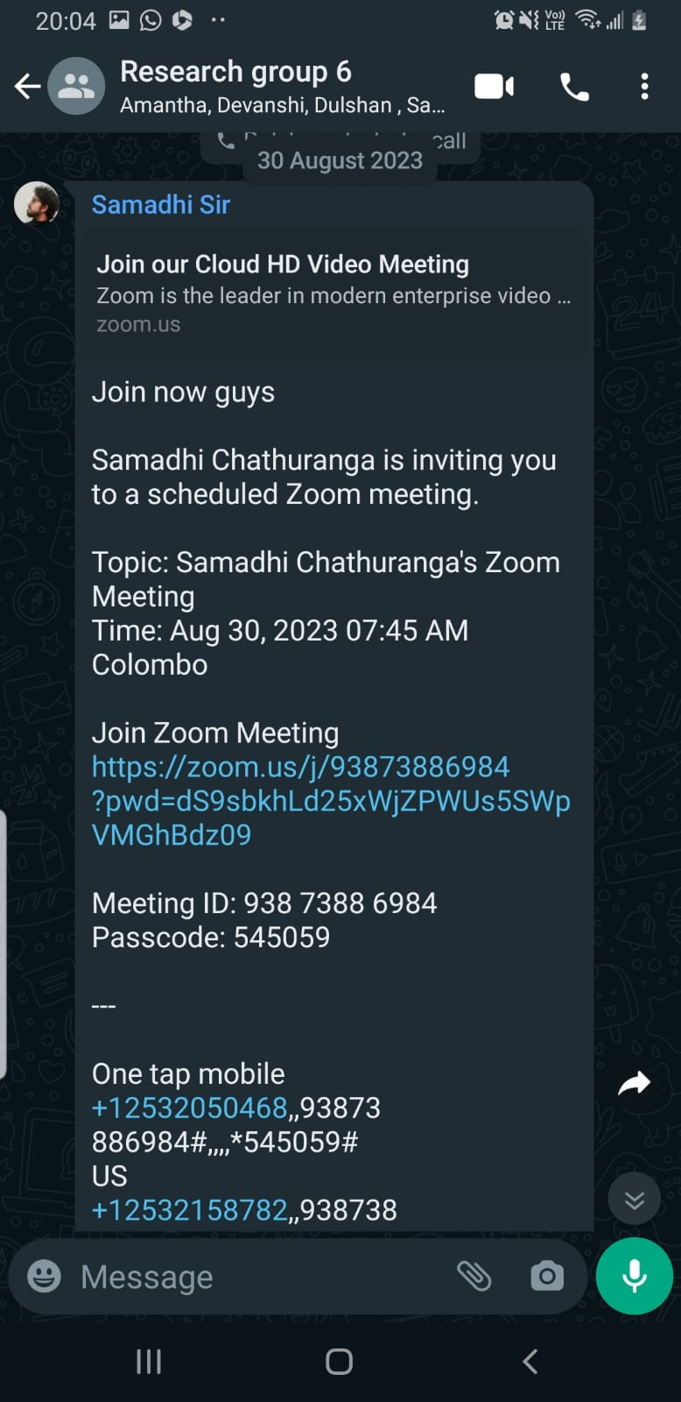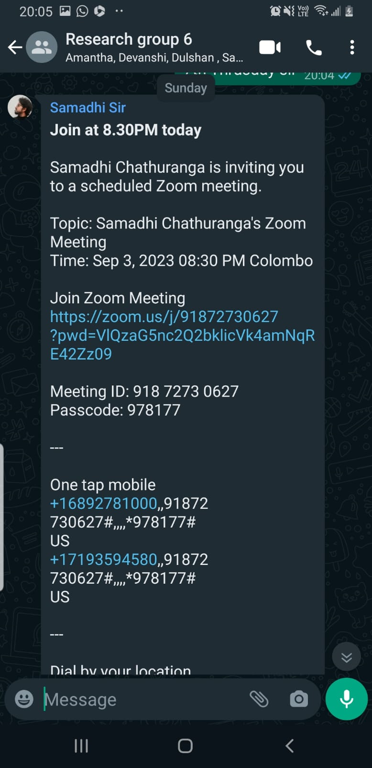

## 5.2 MEETINGS WITH THE CO-SUPERVISOR (MS. DEVANSHI GANEGODA)

Our co-supervisor also guided us through different phases of the project. Though the meetings were not as frequent as with the supervisor, it helped us navigate challenges, and make informed decisions.

|  |  |  |
| --- | --- | --- |
| **Date** | **Reason** | **Mode** |
| 05/08/2023 | Discuss about the current progress of the project | Physical |

## 5.3 MEETINGS WITH THE EXTERNAL SUPERVISOR - PYSCHOLOGIST (MS. AROSHA DASSANAYAKE)

Since the research project was related to stress monitoring and stress relieving, it was important that we consult a psychologist as our external supervisor. The following are the meetings we took with the external supervisor for the betterment of our project.

|  |  |  |
| --- | --- | --- |
| **Date** | **Reason** | **Mode** |
| 14/08/2023 | Status of the research was conveyed to the external supervisor | WhatsApp Call |
| 29/08/2023 | Meeting with external supervisor regarding concerns for resolving issues within the psychological domain | Microsoft Teams |

**GOOGLE MEETS Meeting on 15/03/2023**

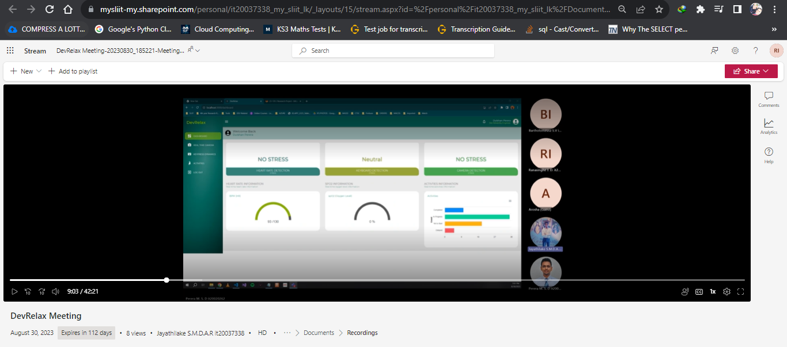

## 5.4 MEETINGS WITH THE EXTERNAL SUPERVISOR – CEO AT XINOTECH (MR. THILANGA JAYARATNE)

For the commercialization aspect of our product, we decided to consult guidance from an IT organization. The commercialization plan was discussed with him and we received a lot of feedback and support from the discussions held.

|  |  |  |
| --- | --- | --- |
| **Date** | **Reason** | **Mode** |
| 19/08/2023 | Discuss about the current progress of the project and the testing phase with the company | Physically |

## 5.5 MEETINGS WITH THE TEAM

Several meetings were held with the team while there was also a scheduled recurring Teams meeting which was held once every week to discuss the progress of the project. Apart from this, WhatsApp calls were used to coordinate small matters while Google Meets was used as the platform to discuss issues in the development phase. Moreover, a WhatsApp group is also maintained by the team to discuss frequent updates regarding the research project.

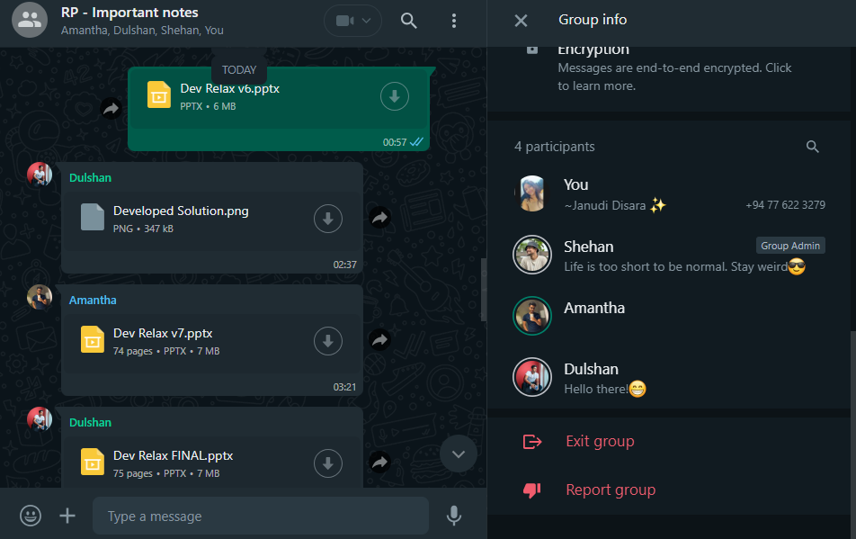

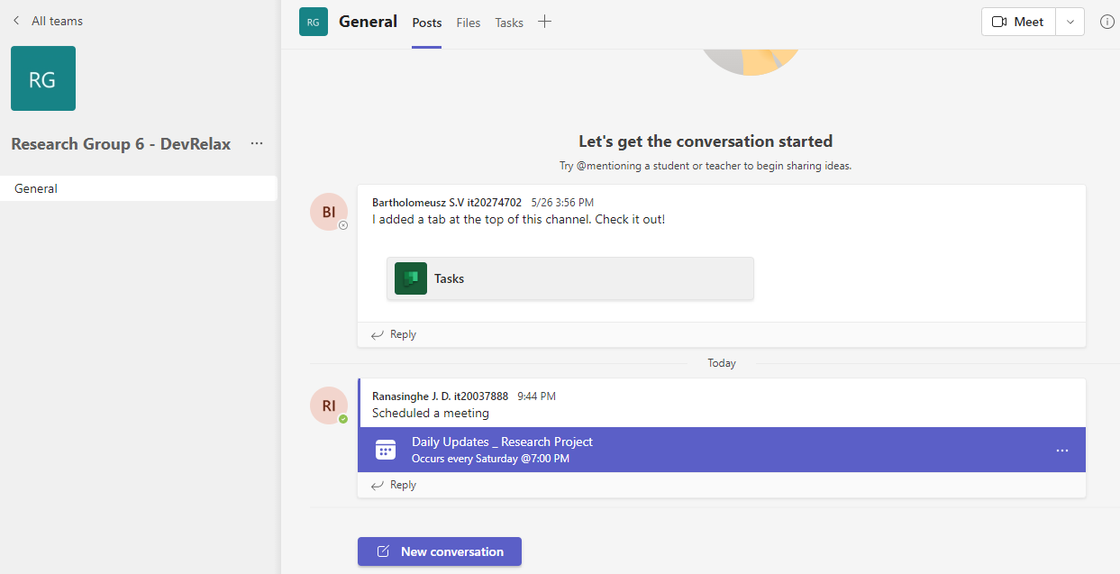

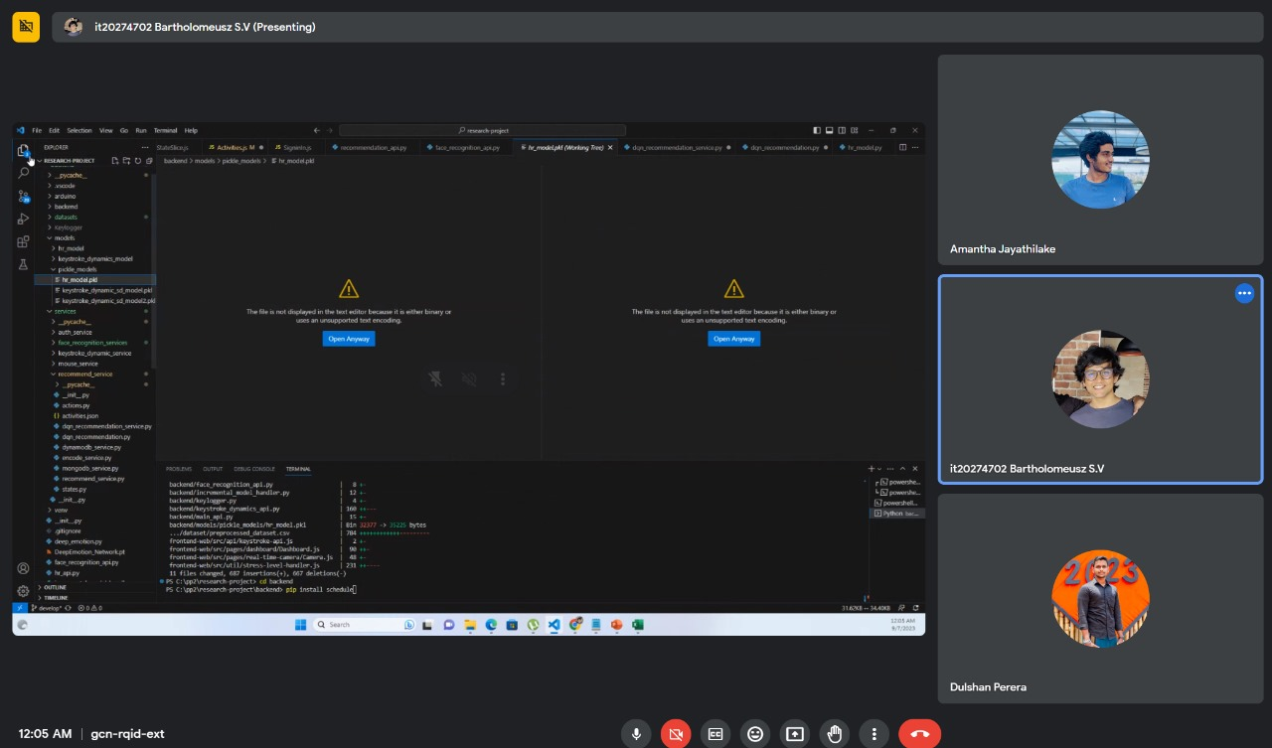

# OTHER ACTIVITIES

## 6.1 NBQSA NATIONAL ICT AWARDS COMPETITION

Our research group was nominated by SLIIT and selected for the NBQSA National ICT Awards competition 2023. We were able to compete in the competition, held at IIT (Informatics Institute of Technology) until the final round successfully.

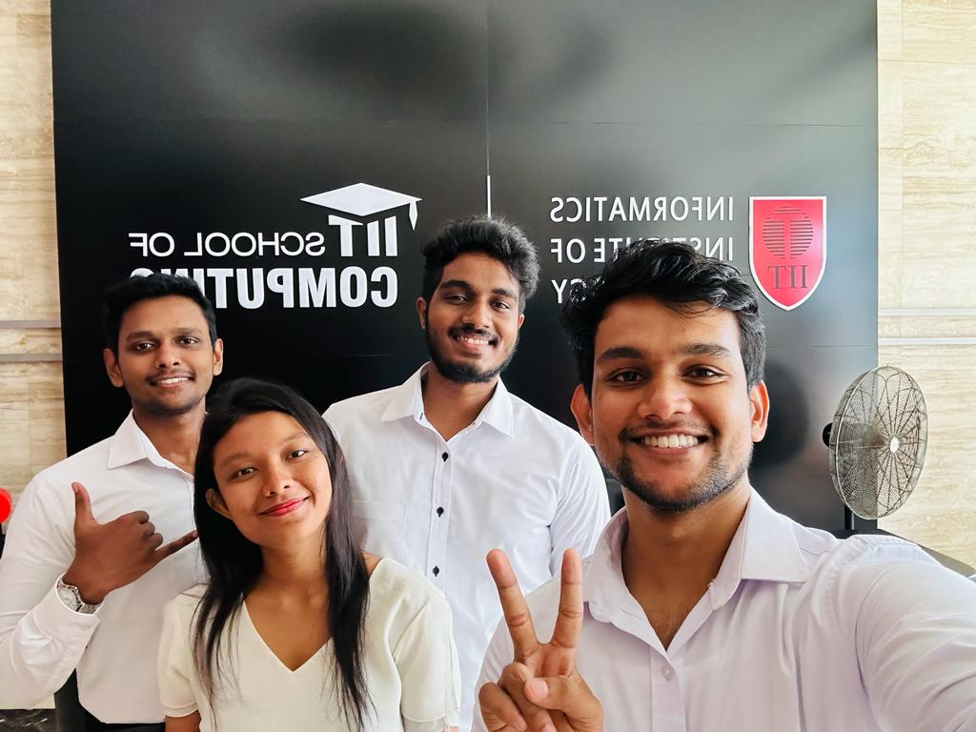

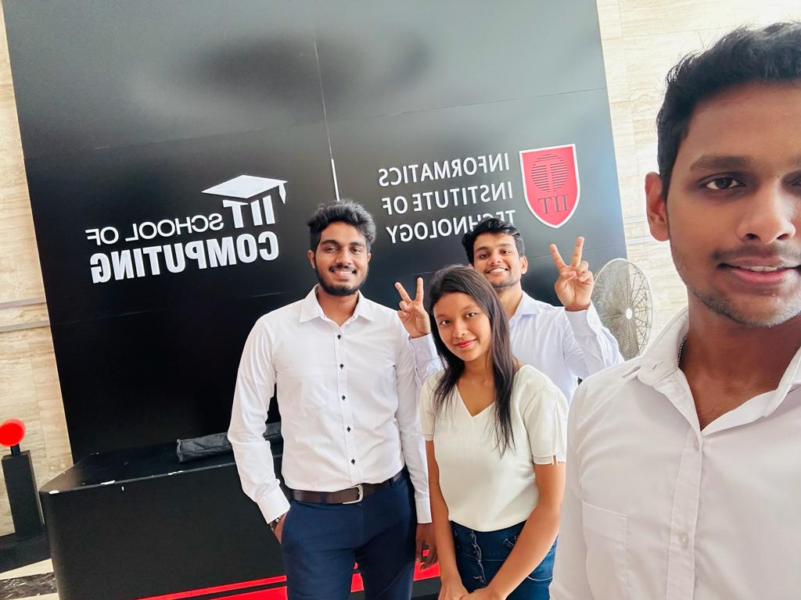

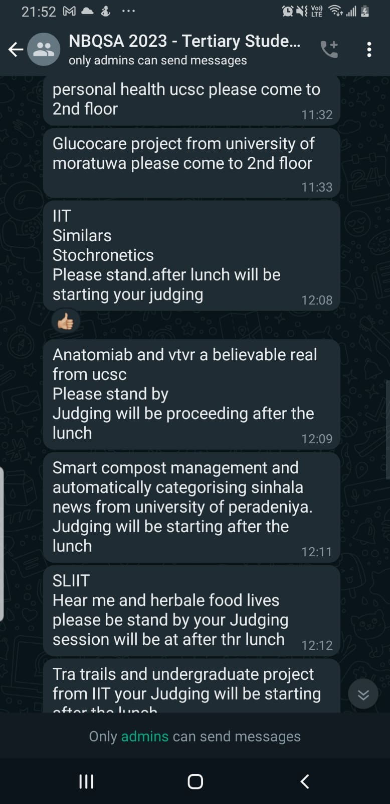

-------------------------------------------- THE END --------------------------------------------